AOC-1 orbital capsule
Specifications and assembly instructions
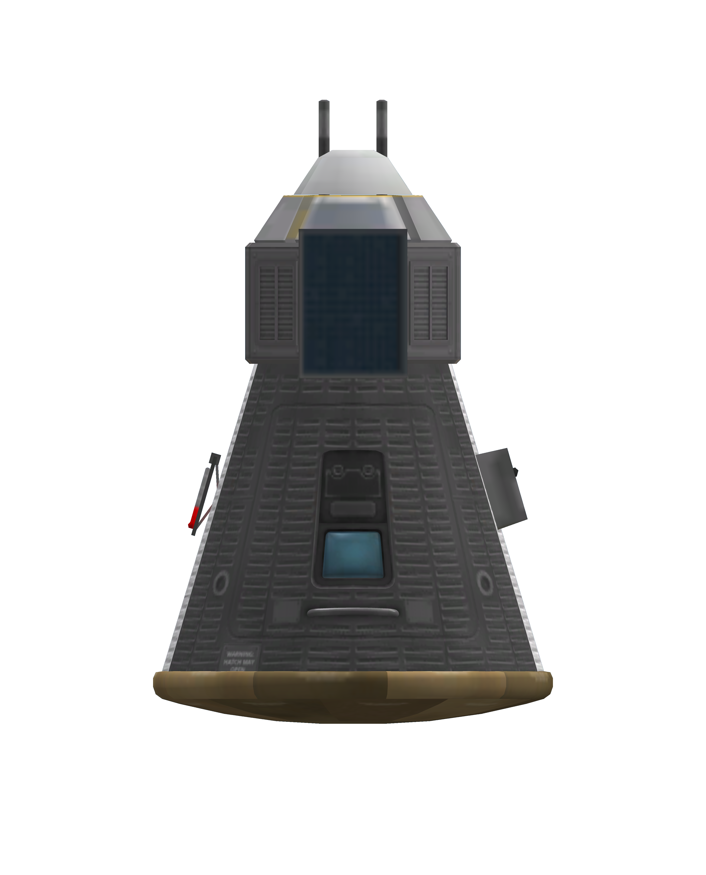
Table of Contents
Description 3
Specifications 3
Assembly and maintenance instructions 3
Parts list 3
Technology needed 3
Assembly procedure 4
AOC-0 conversion instructions 5
General post flight maintenance 5
General pre mission checks 6
Systems 6
Electrical 6
Description 6
System consumption 7
Total EC consumption 7
Life support 7
Attitude control 7
Reaction Wheels 7
Orbital maneuvering 7
Communications 8
Antenna ranges 8
Science 8
Re-entry 8
Landing 8

Description
The AOC-1 is a low tech capsule that can be used for short suborbital or orbital missions. The capsule is powered by a small panel and has a redundant short range radio transceiver. Endurance is limited to 3 days.

Specifications
Parameter | Value | Unit | Notes
Mass | 1161 | Kg | Fully loaded
Total EC | 310 | Units
EC consumption | 0.11 | EC/sec | Radios+computer+sensors
EC consumption | 0.095 | EC/sec | 2 radios and computer
EC consumption | 0.075 | EC/sec | 1 Radio and computer
EC consumption | 0.056 | EC/sec | 1 Radio, computer hibernating
EC consumption | 0.055 | EC/sec | Computer only
EC consumption | 0.036 | EC/sec | Life support only, all hibernating

Assembly and maintenance instructions

Parts list
1x Mk1 Command Pod
1x Probodobodyne OKTO
1x OX-STAT Photovoltaic panel
1x Heat Shield (1.25m)
1x Mk16 Parachute
2x Communotron 16-S
1x 2HOT Thermometer
1x PressMat Barometer

Technology needed
The capsule needs a level 5 technology level on a single branch.
- Start
  - Command pod
  - Parachute
- Engineering 101
  - Thermometer
  - Radio
- Survivability
  - Heat shield
  - Barometer
- Electrics
  - Solar panel
  - OKTO

Assembly procedure
- Start with Mk1 pod
  - Drain all monopropellant
  - Remove all equipment from inventory slots
  - Set spare parts to 5
- Install heat shield axially on bottom of capsule
  - Set ablator to 0
- Install OKTO computer axially on top of capsule
  - OKTO name tag on window side
  - Set "Hibernate on warp" to "Auto"
  - Set "Hibernate" to "Off"
  - Set battery flow priority to -1
- Install radio antennas radially on pod
  - 2x Mirror symmetry
  - Move outward so that radio bodies lie at the edge of the sides of the OKTO panel
  - Rotate so that casing rests solidly on computer (at 0 degrees)
  - Move downwards until bottom of casings touch bottom of computer panel
  - Radio bodies should be centred in height
  - Antennas should embed into capsule and extend past computer
  - Antennas should be parallel to each other
- Install parachutes axially on top of OKTO
  - Angle 0
  - Altitude 1250
  - Pressure 0.6
- Install barometer and thermometer below parachutes
  - On top of white stripe on sides of capsule
  - Barometer to left of hatch, thermometer to right
  - Top of instrument touching eighth notch from the top
  - Second notch after the upper panel break line
- Install OX-STAT panel
  - Line up mounting brackets with OKTO labeled panel
  - Same side as hatch
After assembly, consider keeping a copy of all items rooted in the OKTO and saving them as the capsule’s computer section. This can be used for conversion of AOC-0 capsules into AOC-1.
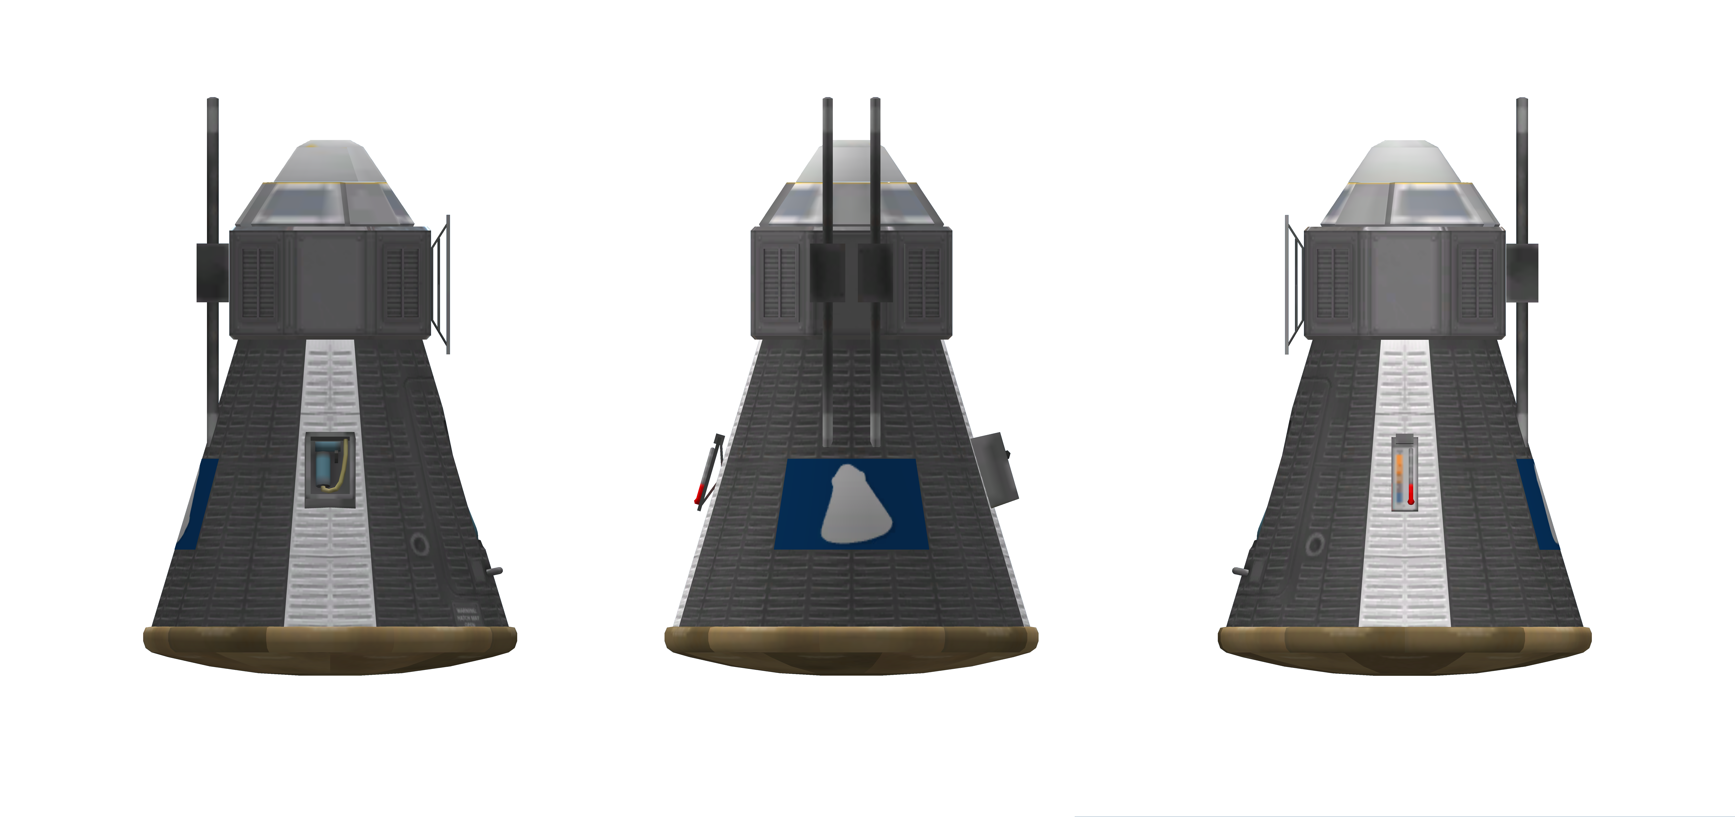Figure 1: AOC-1 showing position of instruments and radios

AOC-0 conversion instructions
To convert an AOC-0 capsule to the AOC-1 standard, perform the following procedures.
Before starting, have an AOC-1 computer section ready.
- Remove Stayputnik computer
- Remove parachutes
- Remove radios
- Reposition thermometer and barometer
  - Slide both up until the top of the instrument touches the eighth notch
- Install computer unit axially on top of Mk1 pod

General post flight maintenance
Part | System | Action | Notes
OKTO | Battery | Fill
OKTO | Command | Check hibernation | Hibernate to off  Hibernate in warp to on
OKTO | Wheel | Active/Normal
Mk1 pod | Battery | Fill
 | Monoprop | Empty
 | Spare parts | 5
 | Food | Fill
 | Water | Fill
 | Oxygen | Fill
 | Carbon Dioxide | Empty
 | Waste | Empty
 | Waste water | Empty
 | Reaction wheels | Active/Normal
Parachutes | Pressure | 0.6
 | Altitude | 1250
 | Deploy | When safe
Radios | Status | Enabled

General pre mission checks
- Check parachute parameters
  - Pressure 0.6 Altitude 1250
- Check radios
  - Both ON
- Check supplies
  - EC full
  - Life support full
- Check computer
  - Not hibernating
  - Auto hibernate in warp

Systems

Electrical

Description
The electrical system is supplied by the Mk1 pod batteries. There is a secondary battery in the Stayputnik computer that is set to be drained after the main battery is drained. The batteries can be charged using the single solar panel present, endurance is not normally limited by electric charge, but by consumables.

System consumption
Class | System | Consumption | Unit | Notes
Computer | Total | 0.02 | EC/sec
 | OKTO | 0.02 | EC/sec | Full operation, divide by 1000 for hibernation
Radios | Total | 0.04 | EC/sec
 | C16-S (right) | 0.02 | EC/sec
 | C16-S (left) | 0.02 | EC/sec
Life support | Total | 0.04 | EC/sec
Attitude | Total | 0.23 | EC/sec
 | Mk1 wheel | 0.2 | EC/sec
 | OKTO | 0.03 | EC/sec
Sensors | Total | 0.0134 | EC/sec
 | Thermometer | 0.0067 | EC/sec | Display active
 |  | 60 | EC | Science transmission
 | Barometer | 0.0067 | EC/sec | Display active
 |  | 90 | EC | Science transmission

Total EC consumption
Situation | Consumption | Unit | Notes
Maneuvering | 0.33 | EC/sec | Sensors inactive
Full op + sensors | 0.1134 | EC/sec
Full operation | 0.10 | EC/sec
Hibernating | 0.08 | EC/sec
Hibernating, 1 radio | 0.06 | EC/sec
Hibernating, no comms | 0.04 | EC/sec | Requires crew to get out of this state

Life support
The life support is a standard TAC LS unit taking supplies from the Mk1 capsule. This is enough to keep a kerbonaut alive for 3 days. The capsule stores consumables for 3 days.
Resource | Endurance | Unit | Notes
Oxygen | 18 | hours
Water | 18 | hours
Food | 18 | hours
Electric power | 2.15 | hours | Recharges using solar panel

Attitude control

Reaction Wheels
There is a redundant wheel system in the capsule. The Mk1 pod houses the primary wheel. There is a second wheel in the OKTO computer which can be used as an emergency control.

Orbital maneuvering
The AOC-1 is not capable of maneuvering in orbit and requires an external service module for all operations, including deorbiting.

Communications
The AOC-1 contains dual Communotron 16-S radios. These are enough to maintain communications when in view of the KSC. The system is capable of keeping in contact with the KSC at a distance of 7620 Km and with an HG-5 equipped satellite at 4479 Km.

Antenna ranges
(assumes root model, 0.5 antenna multiplier and 0.5 multiple antenna bonus)
Situation | Range | Unit | Power | Unit | Notes
Single radio | 750 | Km | 0.02 | EC/sec
Dual radios | 1125 | Km | 0.04 | EC/sec
To compute effective range, employ the root model equation.

where r1 should be the capsule’s range and the r2 range for an HG-5 is 10000Km and KSC is 37500Km.

Science
The capsule has a basic science instrument set containing a barometer and thermometer. These instruments have a storage capacity for one measurement. Data can be moved to the Mk1 pod via EVA or transmitted to KSC via radio.
Transmitting science data imposes a large power drain and should not be done without previous planning.

Re-entry
AOC-1 capsules can re-enter Kerbin’s atmosphere passively. Once contact with the atmosphere is made, the capsule should orient itself in the proper shield first attitude. The shield does not use ablator.
Attaining re-entry attitude requires an external means of propulsion. The AOC-1 capsule is not capable of performing orbital maneuvers.

Landing
Landing is provided by a single Mk16 parachute. In case of failure, use the parachutes attached to the capsule service module, if available.
The main parachute allow a landing speed of 6.4 m/s at sea level. The parachute open partially at an altitude of 3000 m (0.6 pressure) and fully at 1250 metres. They need to be adjusted if the predicted course will cause the landing to happen on mountaineous terrain.
WARNING: Avoid mountains. Plan ahead before executing the re-entry procedure. Consider prematurely opening the parachutes to shorten downrange if necessary.

